Source: http://honda-tech.com/zerothread?id=1265999

The clutch master cylinder looks like this:

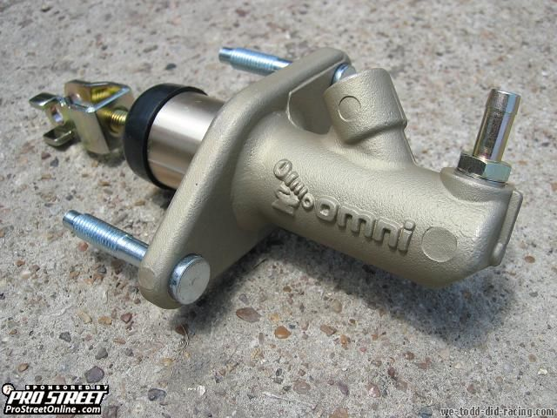

To install, I suggest a standard tool kit with 10 and 12mm deep sockets, a ratchet, 3 inch extension, needle nose pliers, an 8 and 10 mm open end wrench, 10mm line wrench, latex gloves if your skin is sensitive to brake fluid, cheap brake fluid along with whatever fluid you choose, an empty aluminum can and the hose below.

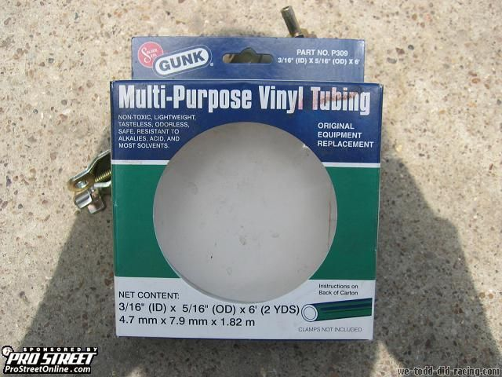

Start off by twisting the tab on the can backwards over the mouth of the can and insert the tube in through it. Take off the rubber nipple that might be on your bleeder screw and put the other end of the hose on it.

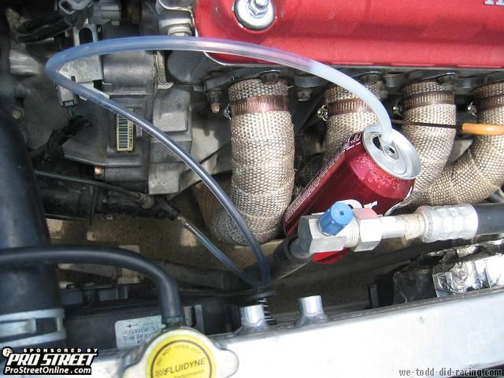

Put the 8mm wrench on the bleeder screw and turn it about 1/4 of a turn towards the front of the car which is counter clockwise. At this point you should see a little fluid drip into the hose.

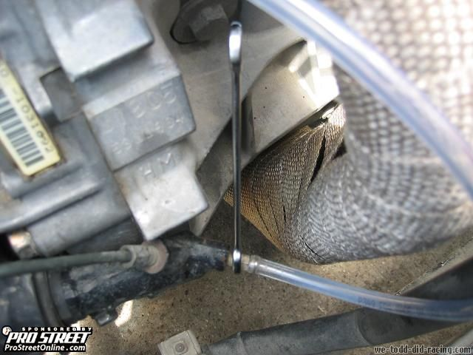

From there locate the clutch master cylinder.

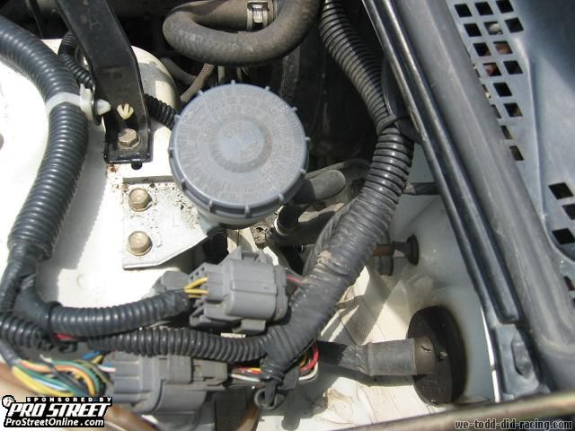

Open the cap and you should discover fluid that is more than likely the same color as mine.

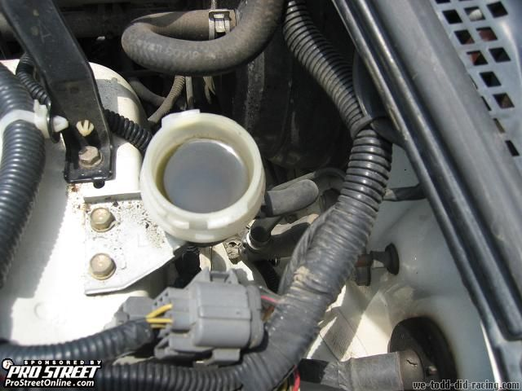

Using your hand, compress and depress the clutch pedal about 10-15 times to drain as much fluid as possible. After the fluid has drained, remove the following 2 10 mm bolts.

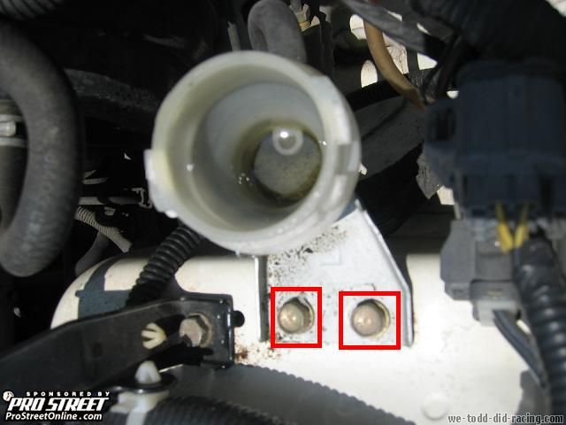

After it's unbolted, move it to the side and locate this clamp which you should be able to easily remove with some needle nose pliers.

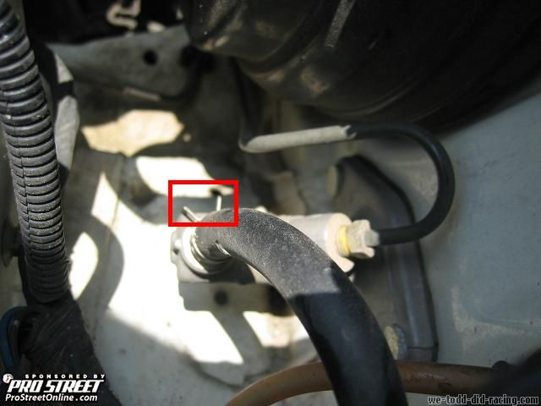

Now locate your line wrench which you should use to break loose the line that goes into the clutch master cylinder.

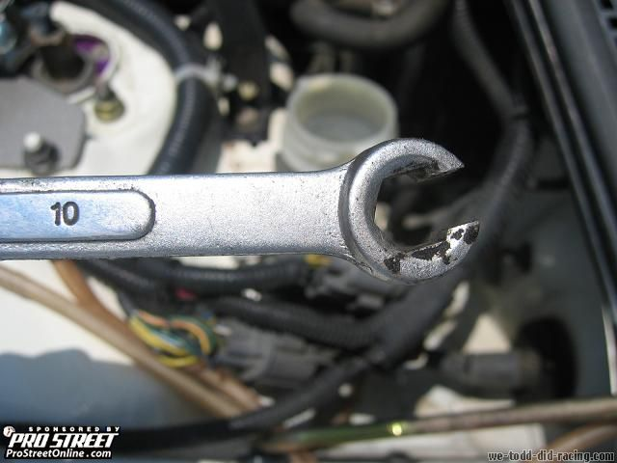

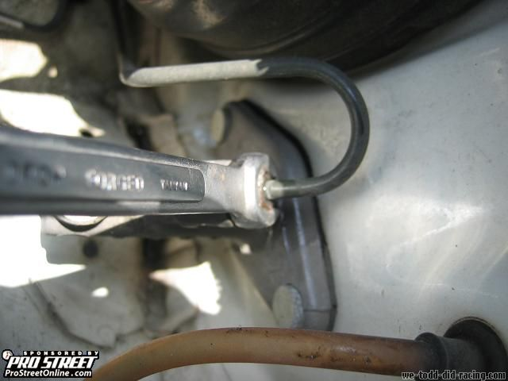
After you break it loose, you should be able to just use a regular wrench to remove the line and push it to the side.

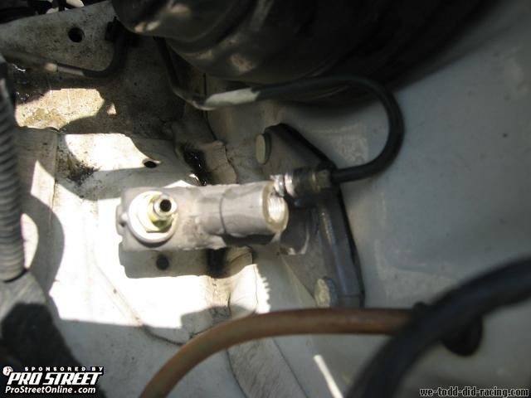

Now move yourself upside down on your driver side and locate these 2 12mm bolts which you will use the 3 inch extension to remove the top one.

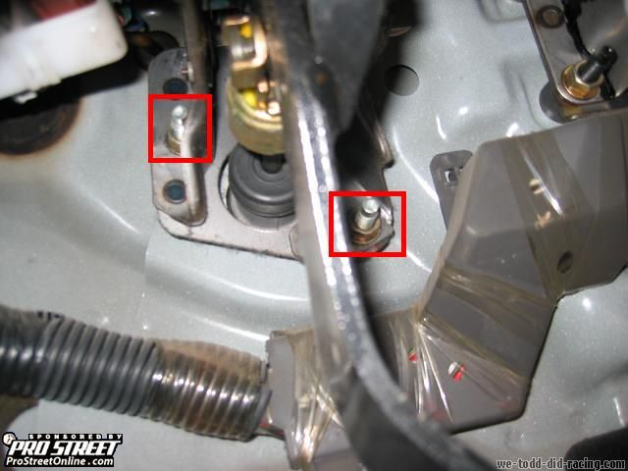

On the right side of the clutch pedal you'll be able to see a cotter pin that holds another pin in place.

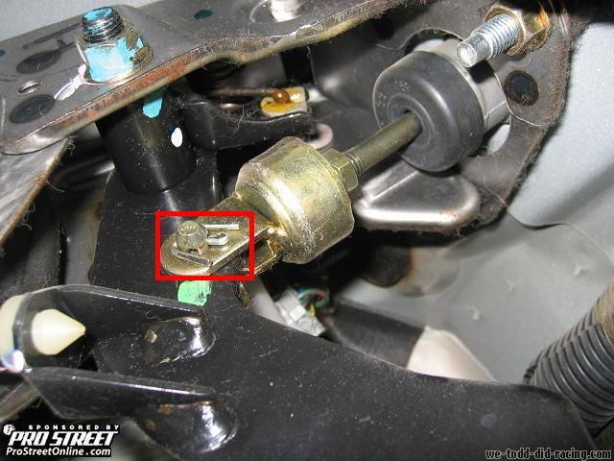

Try to straighten it out as much as possible then pull it out.

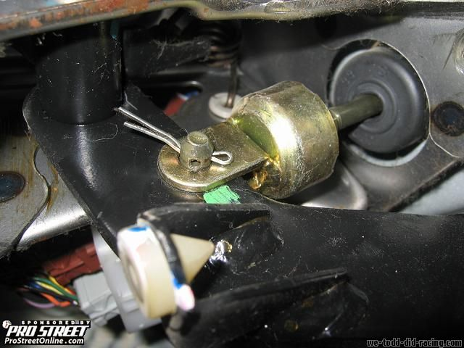

If you can't straighten it out all the way, break one of the legs off and pull it through. Be sure to replace it with a new one if you choose this method of removal.

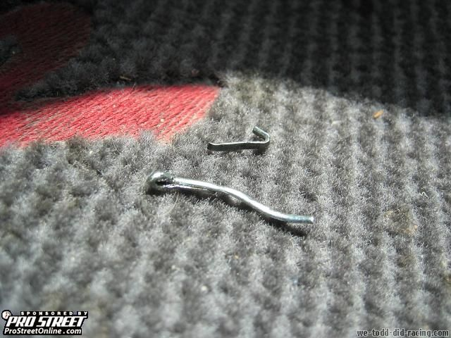

From there, pop out the pin that the cotter pin held in place.

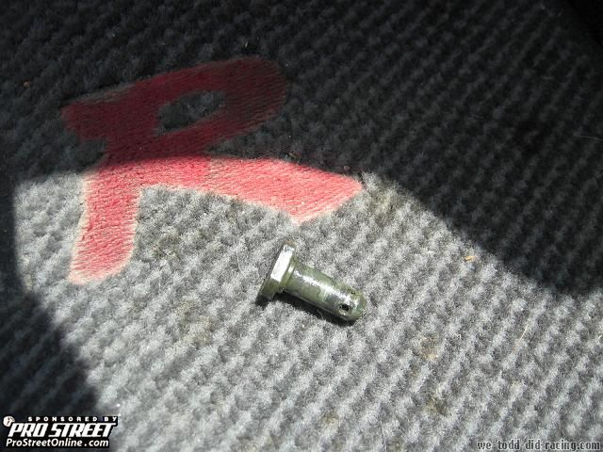

Here are some side by side comparisons of the stock ITR vs. Omni Power.

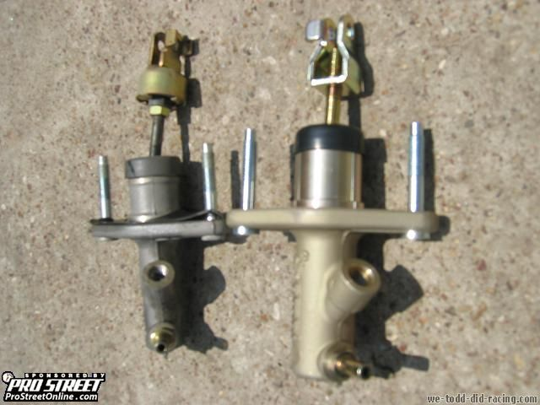

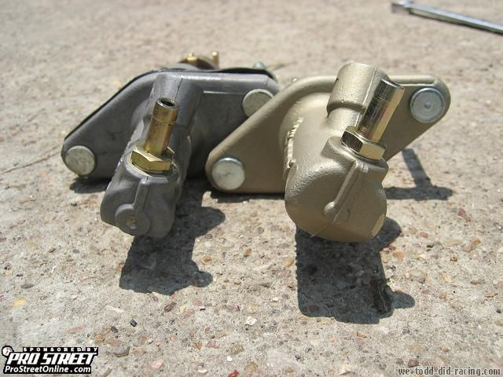

Everything else is pretty much self explanatory....so install in reverse order.
I used a little bit of Teflon tape on the hard line because I don't know what I'm doing, but it's not needed as pointed out by an HT member.
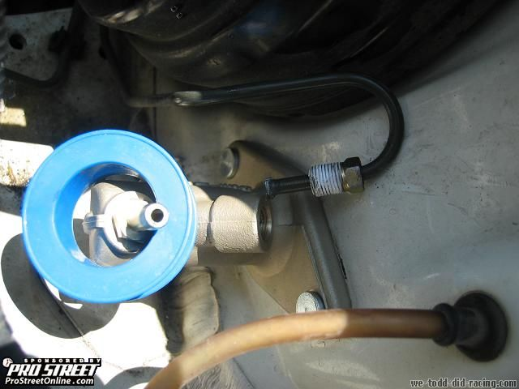

Before I reinstalled the reservoir, I took an old tooth brush and brake parts cleaner to it. You should use a water based solvent which was pointed out to me by another great HT member.

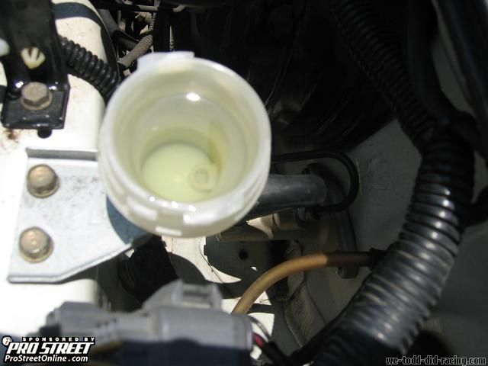

The first 10-15 pumps may not result with anything due to the amount of air in the system, but the fluid will start to go down. Have a friend make sure it stays full or stop every 5 pumps to make sure air doesn't get into the system. Check the hose and make sure there's no air bubbles in it which should mean there is no air in the system. At this point, use your nice expensive Motul or ATE to flush out the cheap stuff if desired.
Also, before you install the cotter pin; test drive and adjust it to your liking.
This can be installed by any newbie and took me about 20 min in 90 degree weather by myself.
My first impressions were great. My clutch set up is an OEM clutch with an ACT Prolite. With this installed, it engaged like my ACT Xtreme PP with a street disk. Pedal travel distance was decreased by 40-50% which makes the pedal sit slightly lower than the brake pedal. It feels GREAT. I only wish it came in earlier for Expo, but do enjoy it now.

